**Temperature and humidity sensor:**

Temperature and humidity sensor (or rh temp sensor) is **devices that can convert temperature and humidity into electrical signals that can easily measure temperature and humidity**.

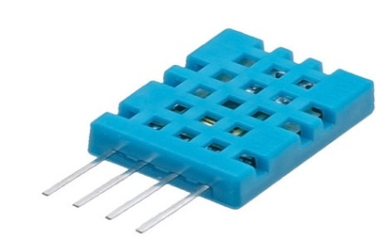

**Working Principle of DHT11 Sensor**

DHT11 sensor consists of a capacitive humidity sensing element and a thermistor for sensing temperature.  The humidity sensing [capacitor](https://www.elprocus.com/construction-of-capacitor-with-working/) has two electrodes with a moisture holding substrate as a dielectric between them. Change in the capacitance value occurs with the change in humidity levels. The IC measure, process this changed resistance values and change them into digital form.

For measuring temperature this sensor uses a Negative Temperature coefficient thermistor, which causes a decrease in its resistance value with increase in temperature. To get larger resistance value even for the smallest change in temperature, this sensor is usually made up of semiconductor ceramics or polymers.

The temperature range of DHT11 is from 0 to 50 degree Celsius with a 2-degree accuracy. Humidity range of this sensor is from 20 to 80% with 5% accuracy. The sampling rate of this sensor is 1Hz .i.e. it gives one reading for every second.  DHT11 is small in size with operating voltage from 3 to 5 volts. The maximum current used while measuring is 2.5mA.

DHT11 Sensor

DHT11 sensor has four pins- VCC, GND, Data Pin and a not connected pin. A pull-up resistor of 5k to 10k ohms is provided for communication between sensor and micro-controller.

Pin diagram:

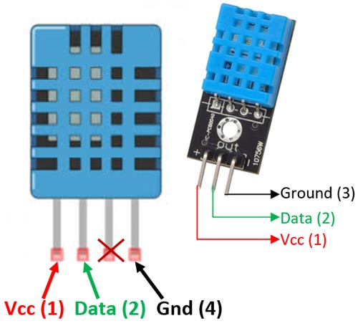

Code:

#include <dht.h>

#define dht_apin A0 // Analog Pin sensor is connected to

dht DHT;

void setup(){

Serial.begin(9600);

delay(500);//Delay to let system boot

Serial.println("DHT11 Humidity & temperature Sensor\n\n");

delay(1000);//Wait before accessing Sensor

}//end "setup()"

void loop(){

//Start of Program

DHT.read11(dht_apin);

Serial.print("Current humidity = ");

Serial.print(DHT.humidity);

Serial.print("% ");

Serial.print("temperature = ");

Serial.print(DHT.temperature);

Serial.println("C ");

delay(5000);//Wait 5 seconds before accessing sensor again.

//Fastest should be once every two seconds.

}// end loop(

Output:

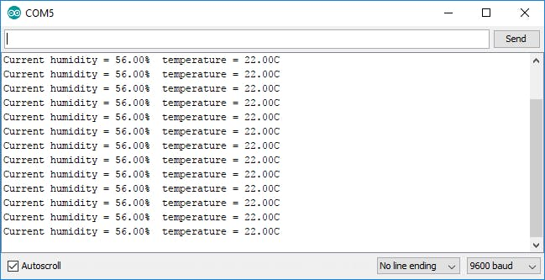

## Soil Moisture Sensor

The soil moisture sensor is one kind of sensor used to gauge the volumetric content of water within the soil. As the straight gravimetric dimension of soil moisture needs eliminating, drying, as well as sample weighting. These sensors measure the volumetric water content not directly with the help of some other rules of soil like dielectric constant, electrical resistance, otherwise interaction with neutrons, and replacement of the moisture content.

## Soil Moisture Sensor Pin Configuration

## [https://1.bp.blogspot.com/-zIMlh43b3hQ/YEmDPIZW8FI/AAAAAAAAA4Q/xe5yBABwxcUd7NxsVkuh3i3V5z7Iblv0gCLcBGAsYHQ/w640-h360/20210311_080630.png](https://1.bp.blogspot.com/-zIMlh43b3hQ/YEmDPIZW8FI/AAAAAAAAA4Q/xe5yBABwxcUd7NxsVkuh3i3V5z7Iblv0gCLcBGAsYHQ/s1280/20210311_080630.png)

**Soil Moisture working:**

The Soil Moisture Sensor uses capacitance to measure dielectric permittivity of the surrounding medium. In soil, dielectric permittivity is a function of the water content. The sensor creates a voltage proportional to the dielectric permittivity, and therefore the water content of the soil.

The sensor averages the water content over the entire length of the sensor. There is a 2 cm zone of influence with respect to the flat surface of the sensor, but it has little or no sensitivity at the extreme edges. The figure above shows the electromagnetic field lines along a cross-section of the sensor, illustrating the 2 cm zone of influence.

## Working Principle:

This sensor mainly utilizes capacitance to gauge the water content of the soil (dielectric permittivity). The working of this sensor can be done by inserting this sensor into the earth and the status of the water content in the soil can be reported in the form of a percent.

This sensor makes it perfect to execute experiments within science courses like environmental science, agricultural science, biology, soil science, botany, and horticulture.

## Specifications:

* The required voltage for working is 5V
* The required current for working is <20mA
* Type of interface is analog
* The required working temperature of this sensor is 10°C~30°C

**Diagram:**

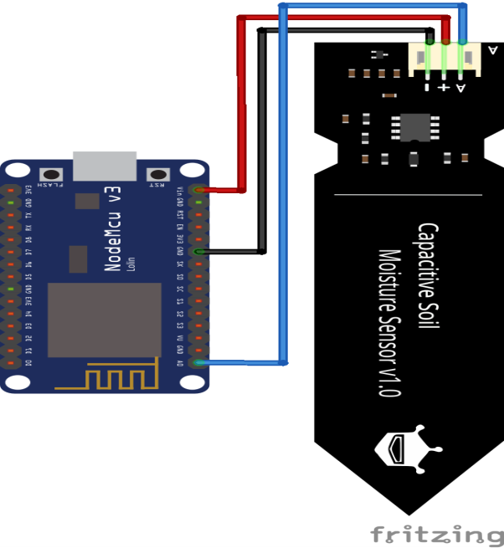

Code:

|  |
| --- |
| int outputValue ; |
|  |
| void setup() |
| { |
| Serial.begin(9600); |
| Serial.println("Reading Data From the Sensor ..."); |
| delay(2000); |
| } |
|  |
| void loop() |
| { |
| outputValue= analogRead(sensorPin); |
| outputValue = map(outputValue,550,0,0,100); |
|  |
| Serial.print("Moisture Value : "); |
| Serial.print(outputValue); |
| Serial.println("%"); |
| delay(1000); |

Ultrasonic sensor

An ultrasonic sensor is **an electronic device that measures the distance of a target object by emitting ultrasonic sound waves, and converts the reflected sound into an electrical signal**.

Diagram:

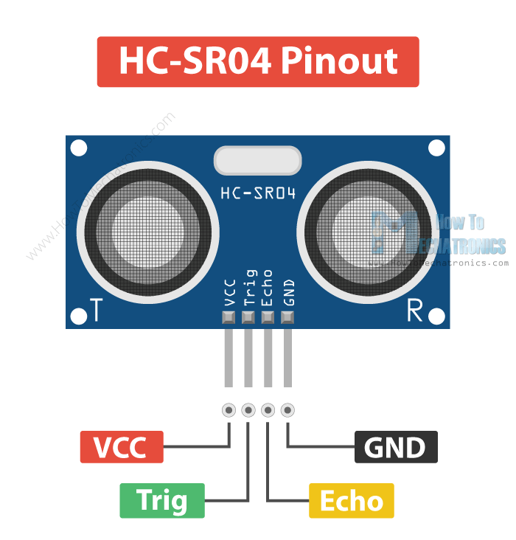

Working:

Ultrasonic sensors emit short, high-frequency sound pulses at regular intervals. These propagate in the air at the velocity of sound. If they strike an object, then they reflected back as an echo signals to the sensor, which itself computes the distance to the target based on the time-span between emitting the signal and receiving the echo. An ultrasonic sensors are excellent at suppressing background interference. Virtually all materials which reflect sound can be detected, regardless of their colour. Even transparent materials or thin foils represent no problem for an ultrasonic sensor. microsonic ultrasonic sensors are suitable for target distances from 20 mm to 10 m and as they measure the time of flight they can ascertain a measurement with pinpoint accuracy. Some of our sensors can even resolve the signal to an accuracy of 0.025 mm. Ultrasonic sensors can see through dust-laden air and ink mists. Even thin deposits on the sensor membrane do not impair its function.

Code:

// Include NewPing Library

#include "NewPing.h"

// Hook up HC-SR04 with Trig to Arduino Pin 9, Echo to Arduino pin 10

#define TRIGGER_PIN 9

#define ECHO_PIN 10

// Maximum distance we want to ping for (in centimeters).

#define MAX_DISTANCE 400

// NewPing setup of pins and maximum distance.

NewPing sonar(TRIGGER_PIN, ECHO_PIN, MAX_DISTANCE);

void setup() {

Serial.begin(9600);

}

void loop() {

Serial.print("Distance = ");

Serial.print(sonar.ping_cm());

Serial.println(" cm");

delay(500);

}

Output:

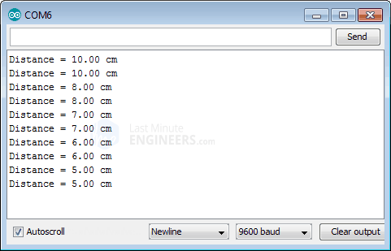I

Infrared sensor:An infrared sensor is an electronic device, that emits in order to sense some aspects of the surroundings. An IR sensor can measure the heat of an object as well as detects the motion. These types of sensors measure only infrared radiation, rather than emitting it that is called a [passive IR sensor](https://www.elprocus.com/passive-infrared-pir-sensor-with-applications/).

Pin diagram:

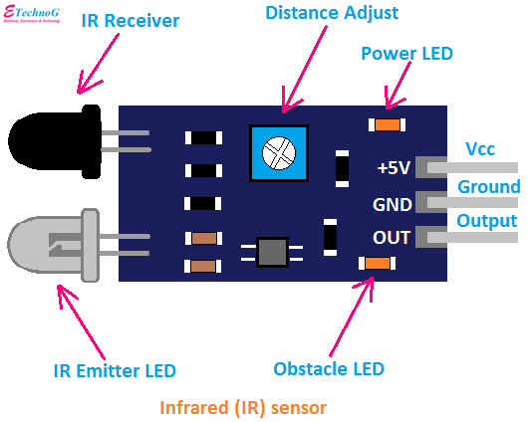

Infrared Sensor

These types of radiations are invisible to our eyes, which can be detected by an infrared sensor. The emitter is simply an IR LED ([Light Emitting Diode](https://www.elprocus.com/explain-different-types-leds-working-applications-engineering-students/)) and the detector is simply an IR photodiode that is sensitive to IR light of the same wavelength as that emitted by the IR LED. When IR light falls on the photodiode, the resistances and the output voltages will change in proportion to the magnitude of the IR light received.

### Working Principle

The working principle of an infrared sensor is similar to the object detection sensor. This sensor includes an IR LED & an IR Photodiode, so by combining these two can be formed as a photo-coupler otherwise optocoupler. The physics laws used in this sensor are planks radiation, Stephan Boltzmann & weins displacement.

IR LED is one kind of transmitter that emits IR radiations. This LED looks similar to a standard LED and the radiation which is generated by this is not visible to the human eye. Infrared receivers mainly detect the radiation using an infrared transmitter. These infrared receivers are available in photodiodes form. IR Photodiodes are dissimilar as compared with usual photodiodes because they detect simply IR radiation. Different kinds of infrared receivers mainly exist depending on the voltage, wavelength, package, etc.

Once it is used as the combination of an IR transmitter & receiver, then the receiver’s wavelength must equal the transmitter. Here, the transmitter is IR LED whereas the receiver is IR photodiode. The infrared photodiode is responsive to the infrared light that is generated through an infrared LED. The resistance of photo-diode & the change in output voltage is in proportion to the infrared light obtained. This is the IR sensor’s fundamental working principle.

Once the infrared transmitter generates emission, then it arrives at the object & some of the emission will reflect back toward the infrared receiver. The sensor output can be decided by the IR receiver depending on the intensity of the response.

Code: